**11. Gantt Chart**

**The Figure 1** the Gantt chart represents the timeline for the "Play Money – Simple Expense Management Website" project, running from March 20 to May 25, 2025. It includes six main tasks: writing the problem statement, preparing a project plan and analysis, designing the system, implementing and deploying the website, testing the system, and finally, preparing a discussion and PowerPoint presentation. Each task is scheduled sequentially with some overlaps, showing a clear flow from planning to final delivery.

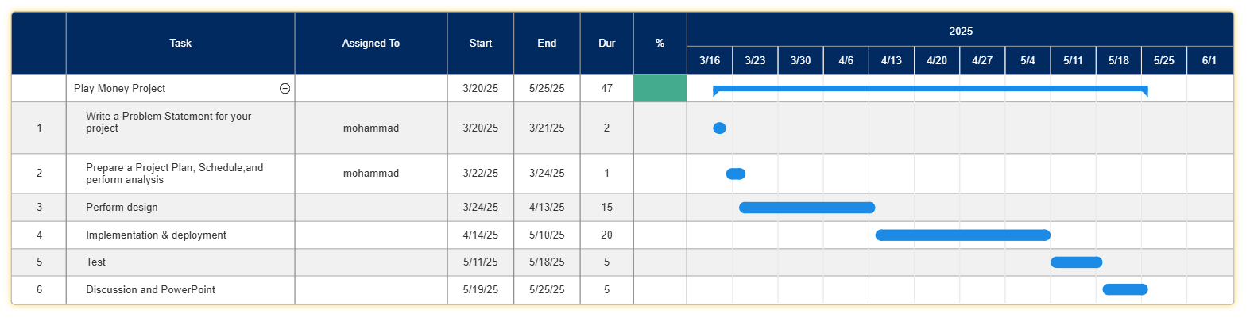

**Figure 1: schedule the project**